Most older workbooks will **NOT** have the demographics columns in them and they have to be inserted *manually*.

Click on **Column A** then **Right Click** and **Insert Column** *repeat 6 times* (CTRL-Y will repeat the last action)

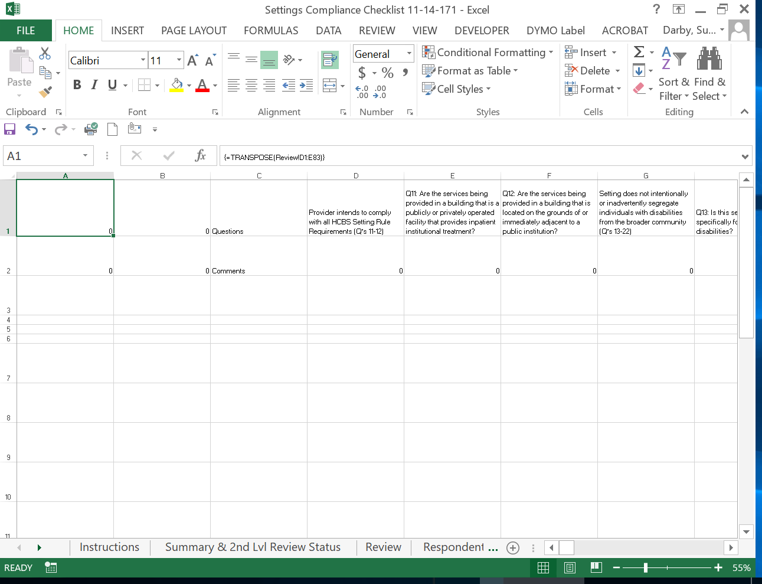

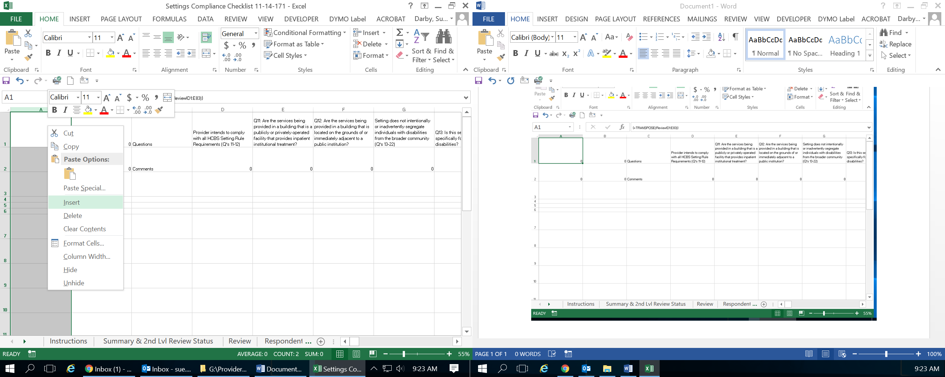

Either type in the column headings or copy and paste from another workbook

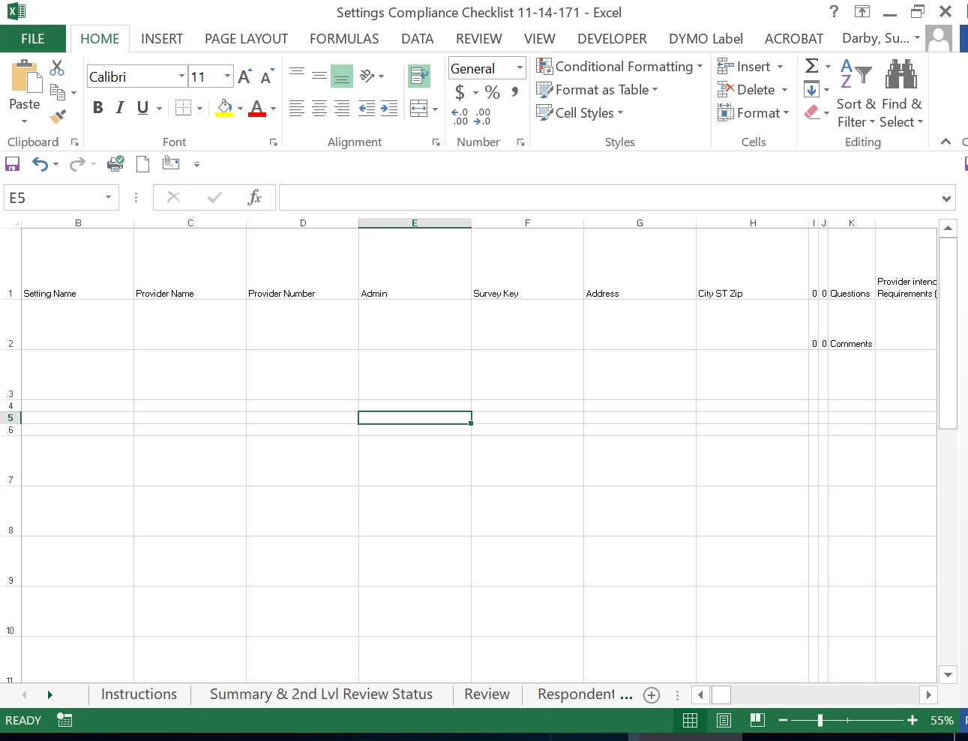

**Insert a new Sheet**

**Right Click** on the **Remediation Tab>Insert**

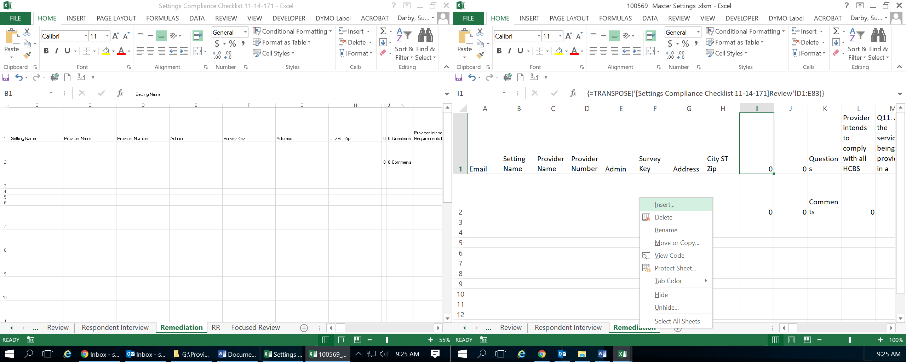

Leave the defaults and click **OK**

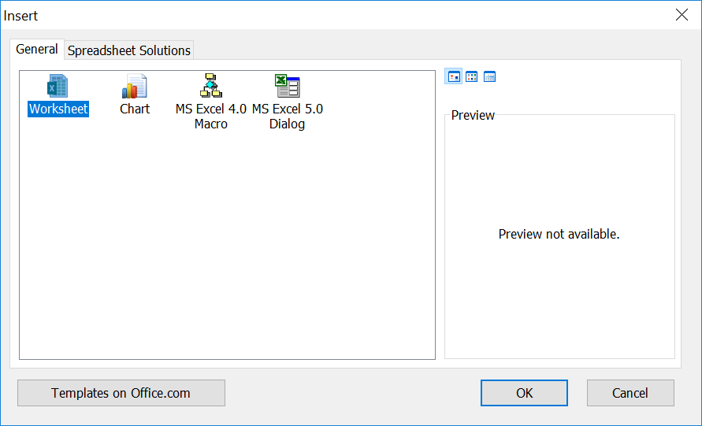

**Right Click** on the **New Sheet** and **Rename** it to **RR**

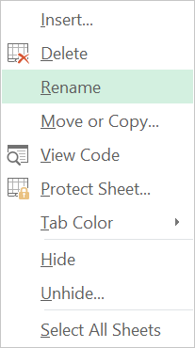

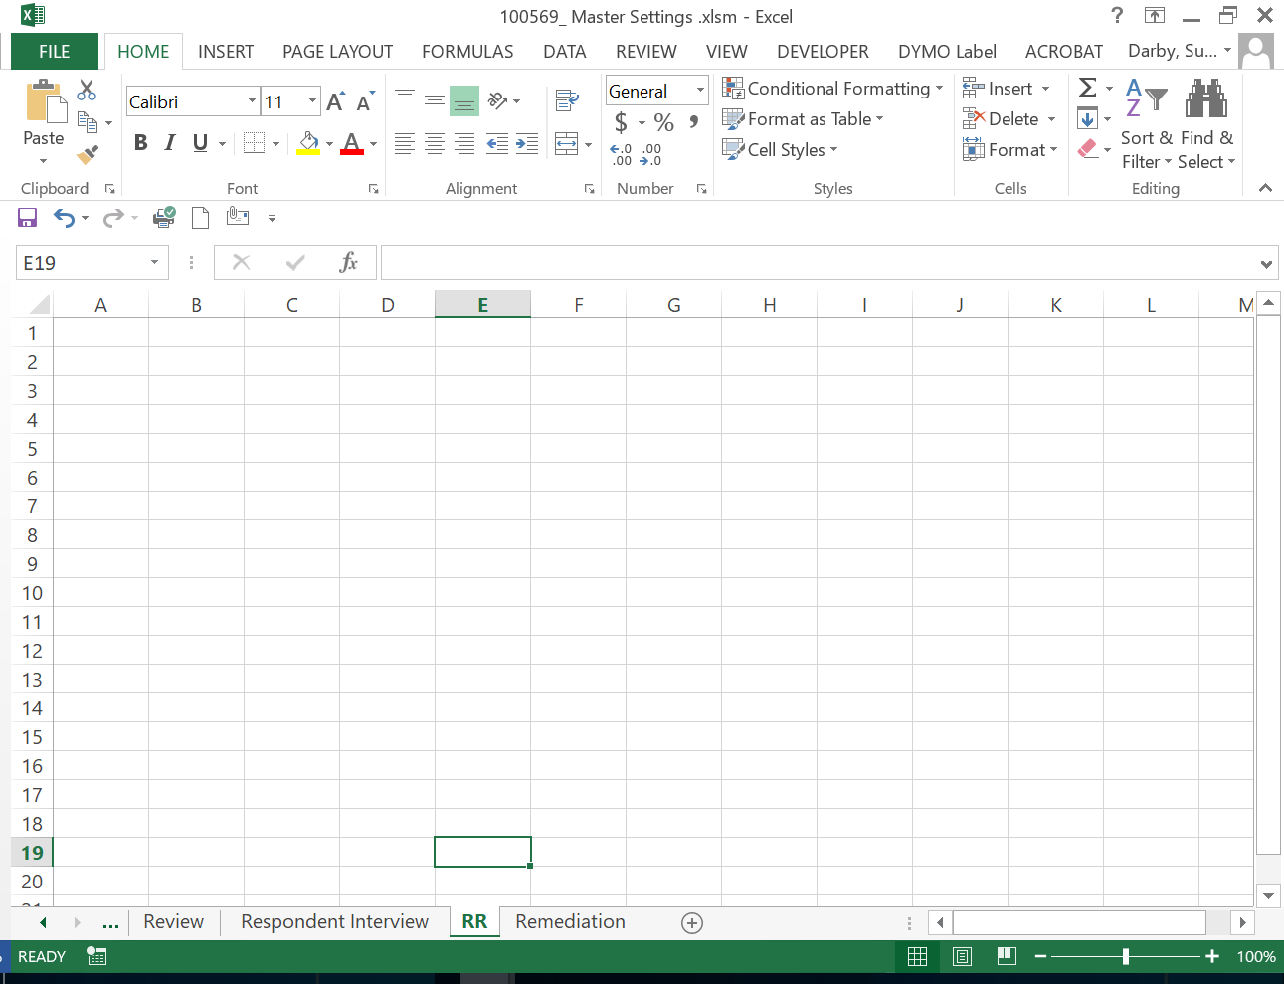

On the *RR Sheet*, in **A1** type **=**

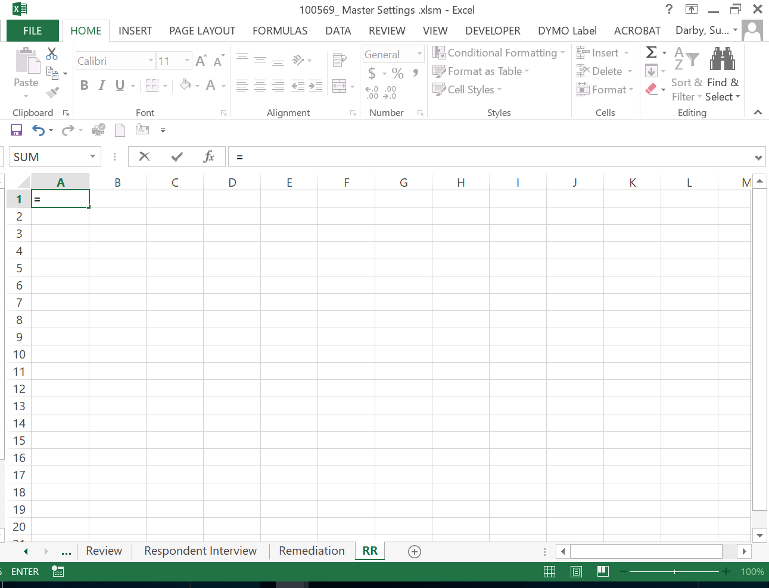

Click on the **Remediation Tab** and click on **A1** and hit **Enter**

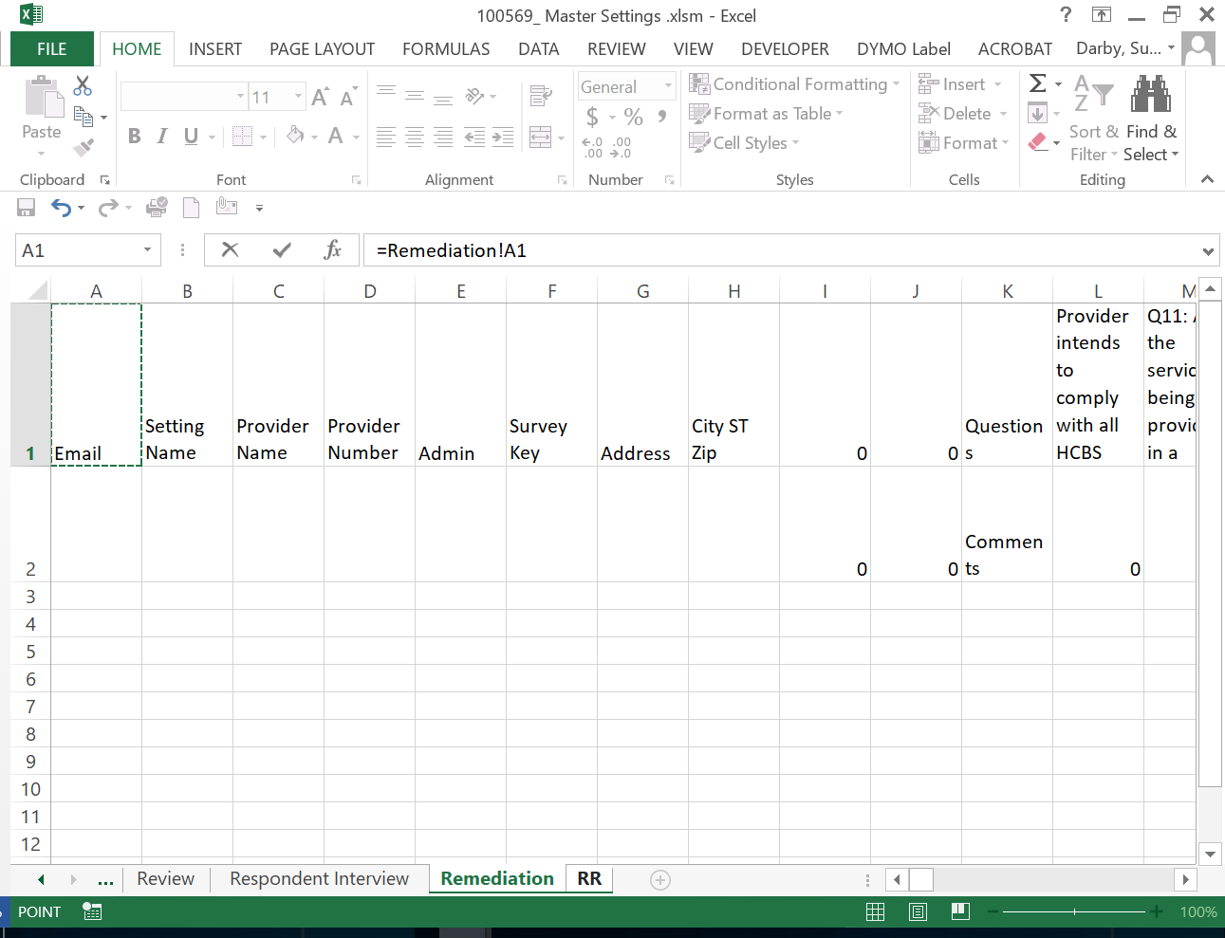

Several things happen, duplicate data from the Remediation tab shows up and Excel inserts a formula

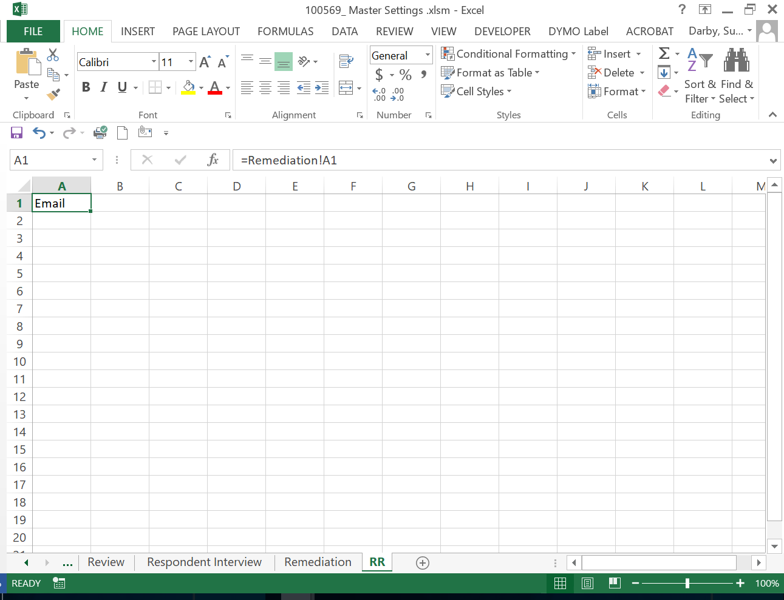

Using the **tiny box** in the *lower right corner* of the cell **click, hold and drag** either across or down until you get what appears below:

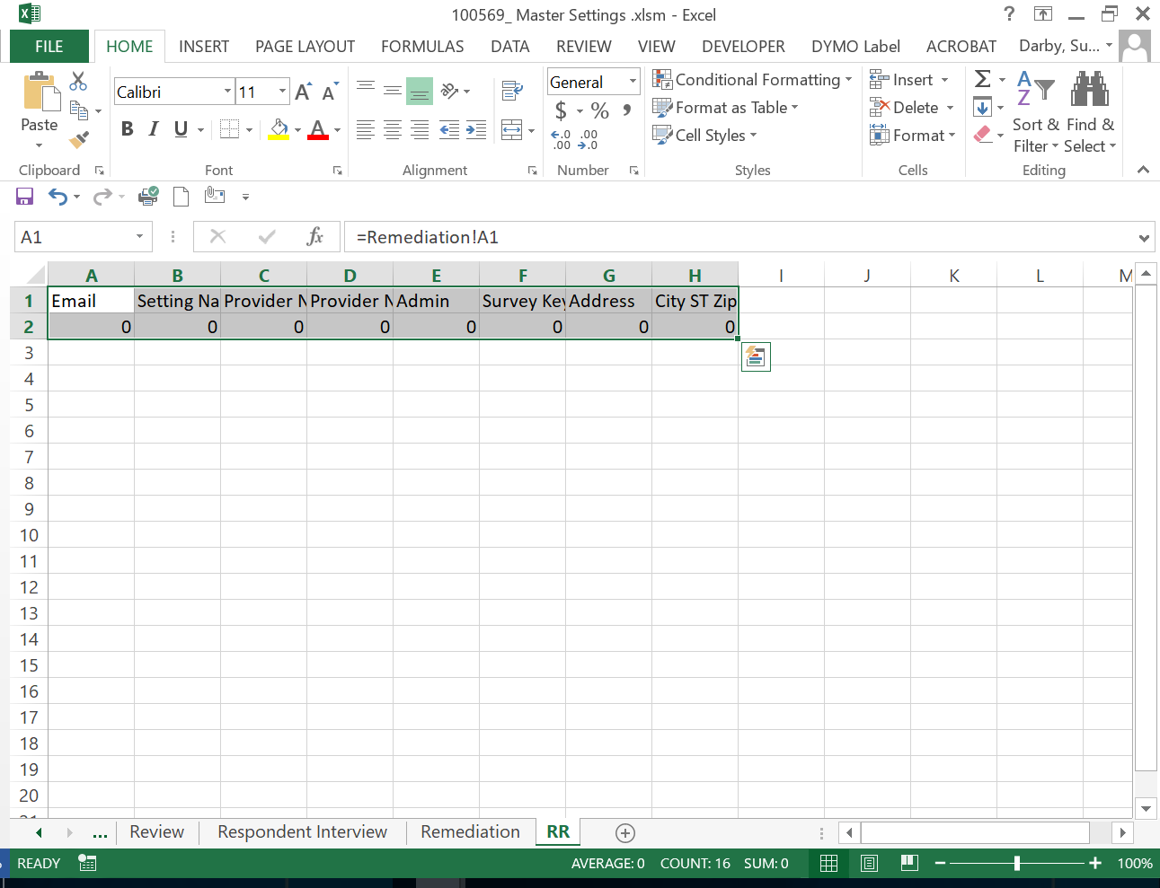

This allows you to fill in the demographics on the *Remediation Tab* and *pre-fill* in the same demographics on the *RR Tab*.

**In the Master Workbook Template**

Click in **I1**, hold **CTRL, Shift and push the Right Arrow 🡪** *once*. Hold down **CTRL-C** (copy)

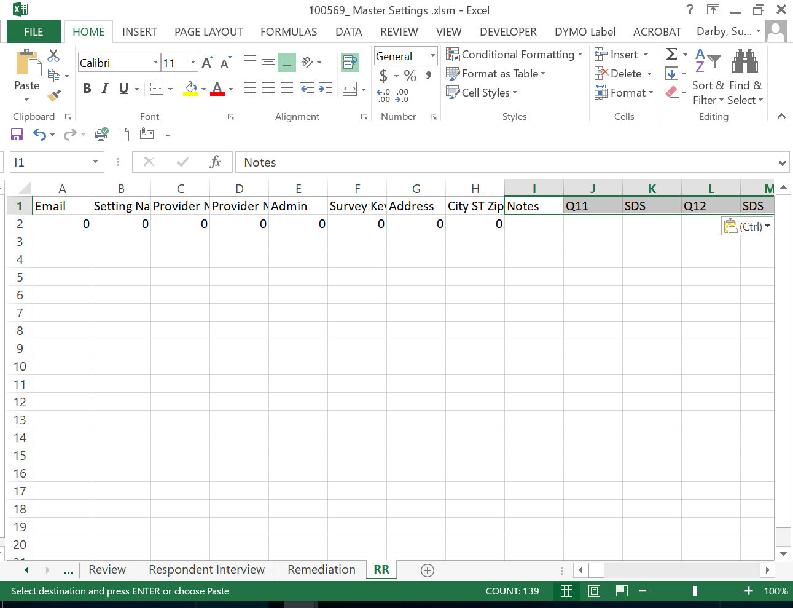

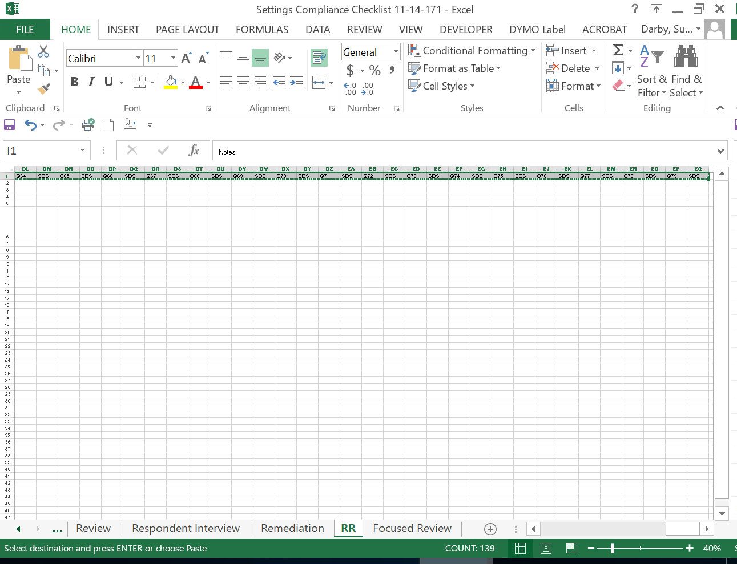

In your target workbook click in **I1** and hold **CTRL-V** to paste the information.

*Highlight* the data in **A6 through L6** in the *Master Workbook*, copy and paste it into your *target* workbook on the *RR Tab*.

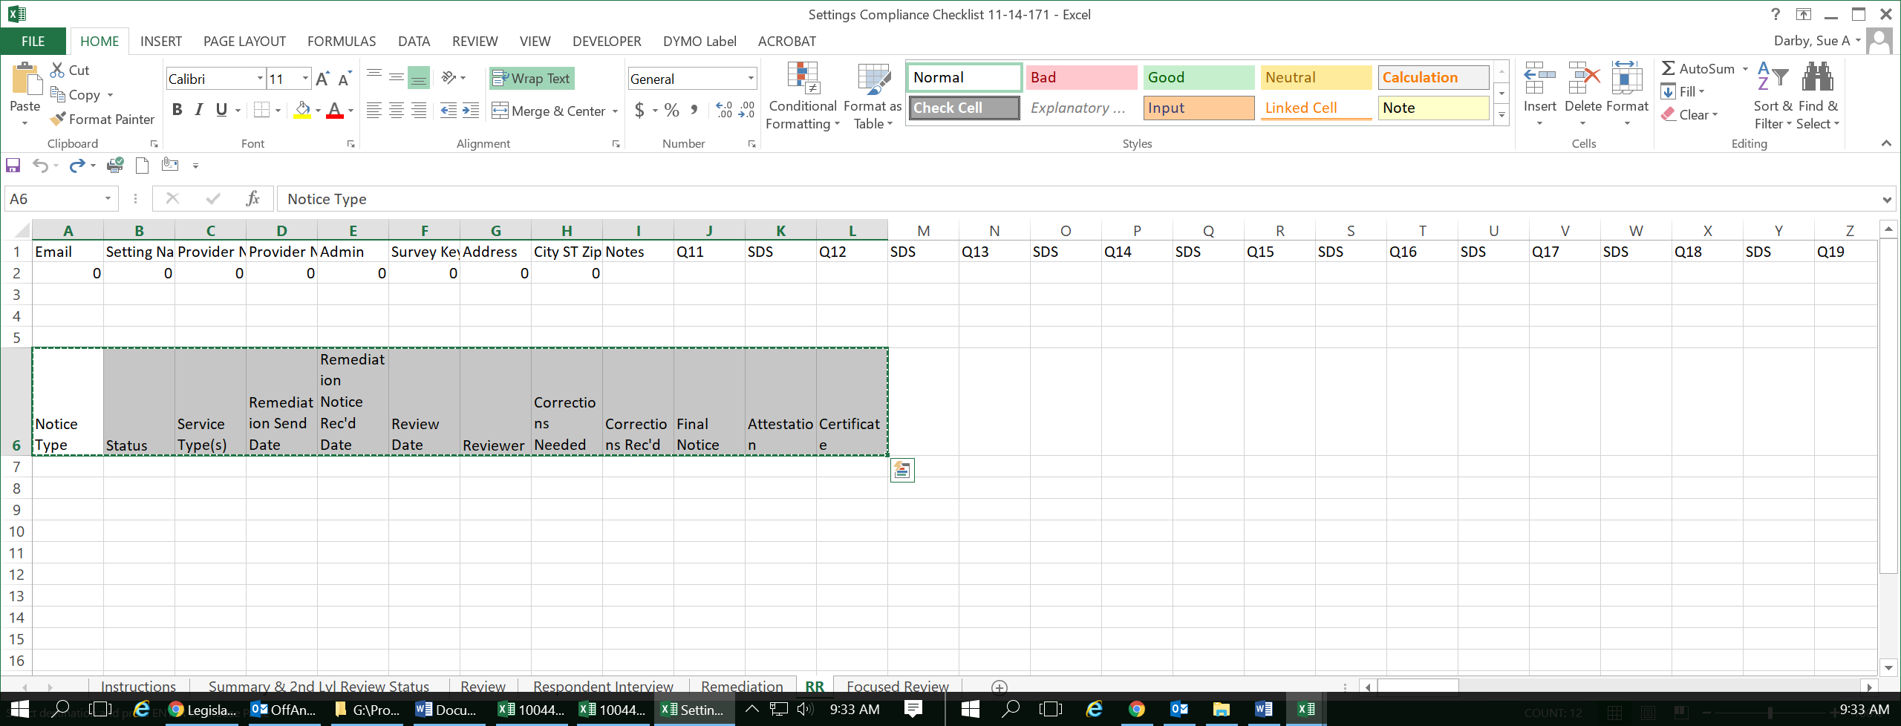

The workbook is now ready for **Remediation Reponses**.